

IMPLEMENT PROCESS

**Version 1.0**

**Thang Nguyen**

**05/05/2017**

**Revision History**

|  |  |  |  |
| --- | --- | --- | --- |
| **Version** | **Date** | **Author** | **Content** |
| 1.0 | 05/05/2017 | Thang Nguyen | Make Implementation process document version 1.0 |

Table of Contents

**1. INTRODUCTION 5**

1.1 PROJECT OVERVIEW 5

1.2 PURPOSE 6

1.3 INTENDED AUDIENCE 6

**2. IMPLEMENT PROCESS 7**

2.1 RESEARCH 8

*2.2* *PREPARE* 9

*2.3* *TRAIN* 10

*2.4* *CUSTOMIZE* 10

2.5 RELEASE 12

**3. REFERENCE 13**

**List of Table**

Table 1. Intended Audience 6

Table 2. Describe Research Step 8

Table 3. Describe Prepare step 9

Table 4. Describe Train step 10

Table 5. Describe Customize Step 11

Table 6 . Describe Release step 12

**List of Figure**

Figure 1. Implement Process 7

1. **Introduction.**
   1. **Project Overview**
   2. **Purpose**

* This document describes in detail the process – which will use to define the Programing Software.
* The process will be started right after the end of Architectural phase, using SRS (Software Requirement Specification) and Detail Design document as the input.
* By the name of this process, the final output will be Process for Coding Phase document.
  1. **. Intend Audience**

|  |  |  |
| --- | --- | --- |
| **Intended Audience** | **Name** | **Reading Suggestions** |
| Implement Leader | * Thang Nguyen | Deploy set of implement process include processes, describes for all member in team can understand and do right process. |
| Programmer | * Nhat Tan * Qui Ngo * Van Phan * Nhuan Tran | Read document to know Implement process and according it to work in Implement phase. |
| Project Manager | * Van Phan | Read to know process of implement phase and tracking progress according to this process. |

Table 1. Intended Audience

1. **Implement Process**

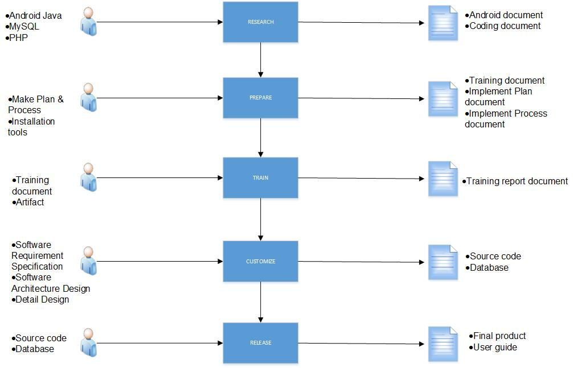

Figure 1. Implement Process

* 1. **Research**

|  |  |
| --- | --- |
| **ID** | **01** |
| **Process Name** | **Research** |
| **Purpose** | Purpose of research phase help implement leader can identify framework , database and language programing necessary before executing project. |
| **Entry & Exit conditions Criteria** | * **Entry:** Implement leader identify language programing , database and framework * **Exit :** have a set of the document about code and framework |
| **Input** | * Android Language * MySQL * Sublime Text ( PHP ) |
| **Output** | * Android document * Coding document |
| **Role** | **Implement leader** |
| **Responsibility** | * Research Android Studio:   Android Studio is basic component help to build the Application   * PHP & MySQL:   Language programing(PHP) and database(MySQL) allow implement leader to code and save data to the database |
| **Tools** | * Microsoft Word |
| **Measurement(s)/Metrics** |  |
| **Training & References** |  |
| **Template** |  |

Table 2. Describe Research Step

* 1. **Prepare**

|  |  |
| --- | --- |
| **ID** | **02** |
| **Process Name** | **Prepare** |
| **Purpose** | Purpose of preparation phase help implement leader can prepare everything necessary before executing training step. |
| **Entry & Exit conditions Criteria** | * **Entry:** Implement leader identify plan & process * **Exit :** have a set of the implement phase document fully and work according to WBS |
| **Input** | * Make Plan & Process * Installation tools : Android Studio , MySQL , Sublime Text |
| **Output** | * Training document * Implement Plan document * Implement Process document * Installation guide document |
| **Role** | **Implement leader** |
| **Responsibility** | * Make Plan & Process :   Implement leader will be scheduled from the beginning and then design set of the process for implement phase .According , implement leader base on tracking and controlling.   * Installation tools:   Before starting training , we have to install tools necessary as Android Studio , MySQL , |
| **Tools** | * Microsoft Word |
| **Measurement(s)/Metrics** | **The finished time of this process**   * 1 day = good (identified all needed factors and stakeholders) * 2 days = average * 3 days = bad |
| **Training & References** |  |
| **Template** |  |

Table 3. Describe Prepare step

* 1. **Train**

|  |  |
| --- | --- |
| **ID** | **03** |
| **Process Name** | **Train** |
| **Purpose** | After prepare step, implement leader will train all knowledge as Android Studio, PHP, MySQL to all member in team until they can understand and apply to the project. |
| **Entry & Exit conditions Criteria** | * **Entry:** The preparation phase is finished * **Exit :** having knowledge overview about the system website. |
| **Input** | * Training document * Artifact |
| **Output** | * Training report document |
| **Role** | **Implement leader** |
| **Responsibility** | * After the preparation is finished , implement leader will train |
| **Tools** | * Microsoft Word, Sublime Text, Xampp, MySQL * Technique : Estimate , Language programming. |
| **Measurement(s)/Metrics** | **Number of function per days**   * 1 function/ day = good * 1 function/ 2 days = average * 1 function/ 3 days = bad |
| **Training & References** | * Trainer : Implement leader. |
| **Template** |  |

Table 4. Describe Train step

* 1. **Customize**

|  |  |
| --- | --- |
| **ID** | **04** |
| **Process Name** | **Customize** |
| **Purpose** | Executing customize according to requirement specification and architecture & detail design document |
| **Entry & Exit conditions Criteria** | * **Entry:** The preparation phase is finished * **Exit :** having set of source code & database. |
| **Input** | * Software Requirement Specification * Software Architecture Design * Detail Design |
| **Output** | * Source code * Database |
| **Role** | **Implement leader**  **Programmer** |
| **Responsibility** | * After that the training is finished , develop team will customize the website system from front-end to back-end. * Before customize , the develop team base on software requirement specification document, architecture and detail design document to custom Android Studio and release source code and database. |
| **Tools** | * Microsoft Word, Sublime Text, Xampp, MySQL server. * Technique : Estimate , Language programming. |
| **Measurement(s)/Metrics** | **Number of function per days**   * 1 function/ day = good * 1 function/ 2 days = average * 1 function/ 3 days = bad |
| **Training & References** | * Trainer : Implement leader , Requirement leader and Architect and Design leader. |
| **Template** | * Detail Design * SAD * SRS |

Table 5. Describe Customize Step

* 1. **Release**

|  |  |
| --- | --- |
| **ID** | **05** |
| **Process Name** | **Release** |
| **Purpose** | This phase will delivery for customer final product which maintain & improve  Otherwise User guide document and Refection. |
| **Entry & Exit conditions Criteria** | * **Entry:** The Customize step is finished. * **Exit :** Final product & guide document. |
| **Input** | * Source code * Database |
| **Output** | * Final product * User guide |
| **Role** | * Implement leader * Programmer |
| **Responsibility** | * Develop team use source code & database sufficient write user guide document and final product for end- user. |
| **Tools** | * Microsoft Word, The burning software |
| **Measurement(s)/Metrics** | **The finished time of this process**   * 1 day = good (all product & guide document are completed ) * 2 days = bad (can accept) * 3 days = very bad (too late progress) |
| **Training & References** |  |
| **Template** |  |

Table 6 . Describe Release step

1. **Reference**